So I’m basically interested in something that can either download youtube subtitles from random videos with correct punctuation and text fully linked, OR a program that can remove blank rows and add punctuation to the auto-generated text that can be downloaded from multiple sites on google, such as: <https://downsub.com/>

Here is how it looks like when I download a txt file through the site I linked above for this youtube video: <https://www.youtube.com/watch?v=8GJlC0TyH1I>

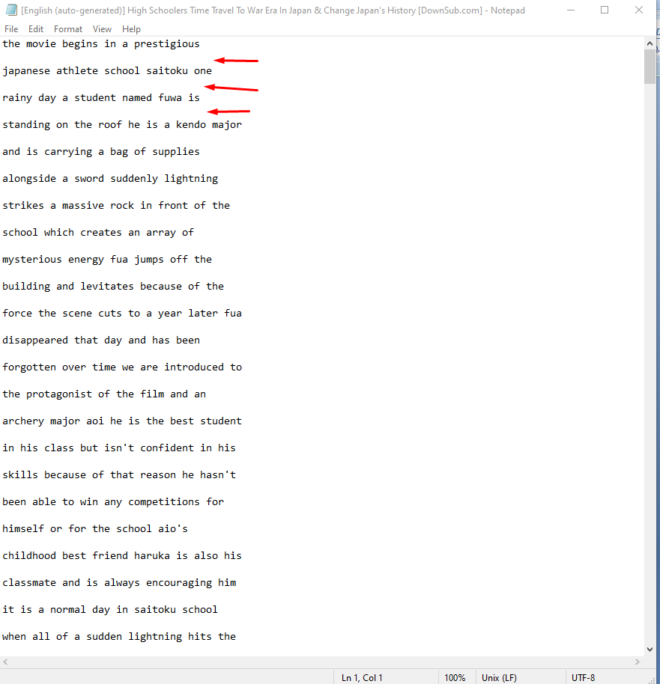

There are blank spaces/rows in between the texts and also there are no dots, commas, etc. I need this text to be connected like a regular paragraph with no blank spaces in between, as well as the “,” “.” etc

I saw on google that there might be some scripts that can generate punctuation to a text file, but I have no knowledge with programming so I’m not sure how to use it. Let me know if it’s something you can do!

Also, if you do manage to make something like that, can it also split the text into paragraphs of 999 characters maximum? Like if I have a text of 3000 characters, make it split into 3~ paragraphs of 900+~ something characters each (not to pass 1000) and then separate them by a blank row like in the screenshot above. (would actually need this feature nonetheless, even if you can’t do the first requirement with punctuation and blank space from youtube CC downloads). Thanks!